**Developing a Flight Delay Prediction Model using Machine Learning.**

### Solution Architecture

MODULES:

• Load dataset: We will upload our dataset into application.

• Data Preprocessing: The quality of the data should be checked before applying our algorithms.

• Feature Extraction: Transforming raw data into numerical features that can be processed while preserving the information in the original data set.

• Generate models: After extracting features from the dataset we will generate our algorithms on that dataset.

• Accuracy Graph: We will plot the accuracies comparison graph between all the algorithms.

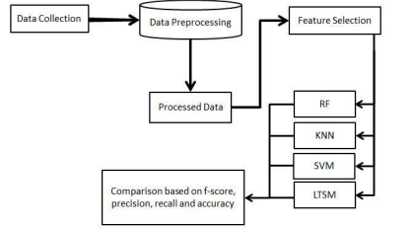

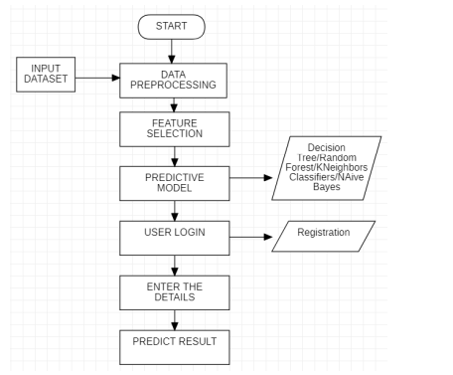

The above figure shows how the machine learning model was built. Deploying a machine learning model includes the following steps namely data collection, input Dataset, data preprocessing ,feature selection, predictive models such as Random Forest Model, Naïve Bayes, Decision Tree and KNeighbors classifier Input Dataset: Input dataset is given to the system to find the desired predicted output. Data preprocessing: Data preprocessing is the process in which the collected data is processed and cleaning the data and suitable for machine learning model so as to make execution efficiently. Feature Selection: Feature Selection is the process where we select the suitable features required for the model and avoiding unwanted data. Predictive Model is that to select the efficient model required and it will predict the result by analysing the existing data. Here after the user registration and then by logging into the system and we have to enter the required essentials. After entering the details in the required fields we can see the result of the flight delay.